ANALYSIS OF FANTASY RUGBY PERFORMANCES

Nicholas Johnson
MSDS 402: Research Design for Data Science
May 5, 2024

Data
Data Description
- Name: KNIME_Assignment_Excel
- Source: API from TheFantasyRuckers.com site, plus a column created by a linear regression
- File format: Excel document
- File size: 111 KB
- Number of Cases: 2307 rows, plus one Column Header row
- Number of Variables: 7
- Types of Variables: Rnd (interval, numerical), Team (nominal, text), Player (nominal, text), Points (ratio, numerical), home (nominal, text), Opp (nominal, text), Forecast (ratio, numerical)
- Collection: Data was copied from API-loaded site on 4/15/2024 for the purpose of analysis by the researcher, loaded into KNIME workflow (Panchwadkar 2023)
Initial Observations and Issues
The most obvious discrepancy is the missing values for Major League Rugby fantasy Points from Rnd 8 to 18 (Major League Rugby 2020), which is the purpose of the study. The aim is to analyze the Forecasted points compared to the Points column, extrapolating to the future matchups, though for this assignment only the past values will be analyzed. The dataset was otherwise cleaned before being collected, so there were not any obvious data quality issues to resolve. There were not duplicate rows to be removed, nor any missing values outside of the expected, and finally no irregular data entries such as points with the wrong decimal place or a Team entry not in the expected set.
Methodology
The file contains both past events with Points recorded as well as empty spots where Points will be assigned in the future. The first step was to read in the Excel using the Excel Reader, followed by removing the missing rows for future performances. Points was being interpreted as a string type due to the empty rows being filled with empty quotes, so the next step was a String to Number node to switch Points to a Number (double) type. The workflow then split into two pathways, “top” and “bottom” as seen in the workflow. The top portion selected columns Points and Forecast to compare the relation for the previously determined forecasts based on a separate linear regression. After a Sorter node ordered the data by Forecast, a Scatter Plot node creates the scatter plot to be later analyzed for Forecast accuracy.
The Sorter was not necessary to the analysis, but creates a cleaner scatterplot. The bottom workflow instead uses the Column Filter to keep Player, Points, and Forecast. Both the sorted information from the top pathway as well as the filtered bottom pathway to this point are put into an Excel Writer node to keep the prepared information in a saved state. Finally the Statistics View node is used to analyze the information in the columns, giving an initial look primarily at the Points and Forecast dataset while the Player column contains player names and is less relevant for statistical analysis. This information is prepared for future work looking at things like player averages and other player-related information.
Workflow
FIGURE 1. KNIME Workflow
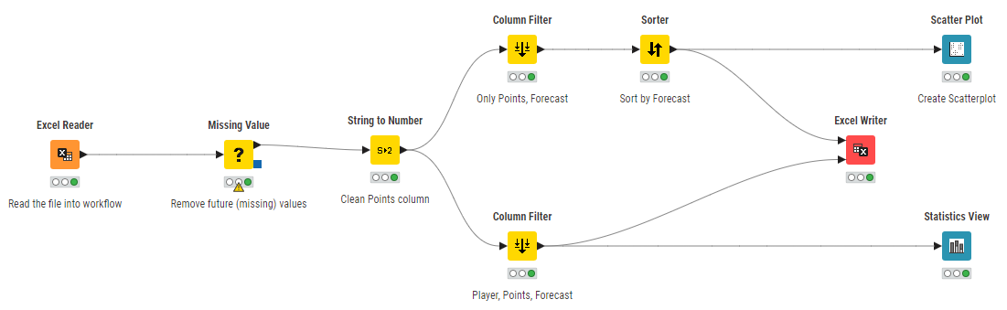Source: KNIME Workflow from Excel document
End Results
Results
The prepped data seems to have a positive linear trend where players forecasted to score high do so, and similarly those projected to score low often did. The trend is not exactly predictive, but a trend is close enough to merit future study. The statistics were not extrapolated far enough to draw any conclusions from based on player information, but a general sense of the values like mean and quantiles could be helpful for directing future study. A histogram may have been more useful at this point in the research. The new datasets were better to analyze in the scatterplot as there were not other columns “in the way” of the analysis, but overall the data was not altered in a way to not have been able to do the analysis without the slight cleanup. The quality and usability of both versions of the dataset were maintained, but the “cleaned” versions were better applicable to the KNIME workflow. Ensuring there are no duplicative data or unknown missing elements makes the data workable for the studies being undertaken.
FIGURE 2. Forecast versus Actual Points through Rnd 7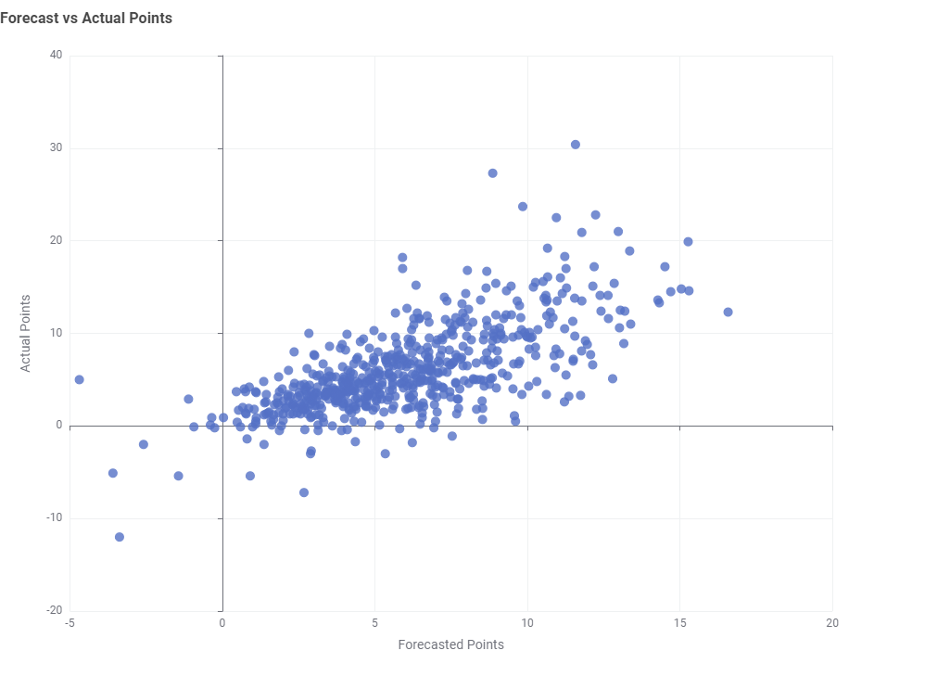
Source: KNIME Workflow from Excel document
Reflection
The no-code, low-code was an interesting experience. This is the first time I’ve worked with a software like this, usually I code in SQL so the code is no issue. However, there are nodes that will do much more than I’m usually able to do, like regression and ML applications which would typically require an additional software or two. I am impressed with the software overall, and will look at this as an option for future analysis. While my thoughts on cleaning and preparing data remain the same as they do in my professional work, the potential seems much larger within KNIME than I would have expected going into this assignment. The limitation I would foresee for myself would be time-based, needing to take more time to work with KNIME and get a feel for it to achieve the exact results (averages, projections, etc.) desired.

References
Major League Rugby. “History.” Major League Rugby, July 6, 2020. https://www.majorleague.rugby/history/.

Panchwadkar, Dipti. “Announcing Knime Analytics Platform 5.1.” KNIME, July 19, 2023. https://www.knime.com/blog/announcing-knime-analytics-platform-51.

